**SECTION A: 50 MARKS**

**SUB-SECTION 1**

**Questions 1 to 50 carry one mark each.**

*In each of the questions* ***1*** *to* ***5****, fill in the blanks with a suitable word.*

1. Father has gone to the court at ......................................... our relatives were charged.
2. The candidate answered all the ......................................... in the examination paper correctly.
3. Miss Agatha will ......................................... some visitors at her home next week.
4. The baker had to knead the dough ......................................... it turned very soft.
5. Stuart is on the ......................................... side because he likes speaking against the motion.

*In the questions* ***6*** *to* ***15****, use the correct form of the word in brackets to complete the sentences.*

1. All the ........................................ met at the hotel to find solutions to road accidents. (lead)
2. Most of the cassava has ........................................ in the gardens a result of the floods. (rot)
3. The cattle usually feed ......................................... along this road without any herdsman. (self)
4. My parents have received an .................................... to our sports day. (invite)
5. Joshua Cheptegei has ........................................ gold medals for Uganda in different athletic competitions. (win)
6. Every person needs protection to avoid ......................................... miserable and unsafe. (to be)
7. Anguzo is the ............................................. of the two police officers at the police station. (friendly)
8. When there is ............................................. in marriage, families develop faster. (agree)
9. Orishaba followed the recipe to prepare the meals .................................. (easy)
10. Katono will face the ............................................. committee because of her bad behaviour at school. (discipline)

*In questions* ***16*** *to* ***17****, give the plural forms of the words.*

1. hutch ........................................................................
2. brother-in-law ........................................................................

*In questions* ***18*** *to* ***20****, rewrite the sentences giving a single word for the underlined group of words.*

1. This motorcyclist does not wear a hard protective hat for the head.

.......................................................................................................

1. We shall discuss the motion in a general way.

.......................................................................................................

1. Nakayima has just charged again her phone.

.......................................................................................................

*In questions* ***21*** *and* ***22****, arrange the given words in alphabetical order.*

1. elephant, chameleon, frog, donkey

.......................................................................................................

1. part, paste, parent, party

.......................................................................................................

*In questions* ***23*** *and* ***24****, write the given abbreviations in their full forms.*

1. a/c ........................................................................
2. Insp ........................................................................

*In each of the questions* ***25*** *and* ***26****, use each of the words in a sentence to show that you know the difference in their meanings.*

1. pull .................................................................................................

.......................................................................................................

1. pool ................................................................................................

.......................................................................................................

*In questions* ***27*** *and* ***28****, rearrange the words in their correct order to make a meaningful sentence.*

1. interested and sports Children are in games.

.......................................................................................................

1. your is What to the school direction?

.......................................................................................................

*In questions* ***29*** *and* ***30****, rewrite the sentences giving the opposite of the underlined word.*

1. Mr. Maloba fastened his shoes with shoe-laces tightly.

.......................................................................................................

1. You must always take bank slips to the bursar.

.......................................................................................................

**SUB-SECTION II**

*In each of the questions* ***31*** *to* ***50****, rewrite the sentences as instructed in brackets.*

1. Both Prossy and Christine are healthy. (Rewrite the sentence using: ……as healthy ………)

…………………………………………………………………………………………………………………………………………………………………………………………………………

1. No sooner had the invigilator entered the classroom than the candidates kept quiet. (Rewrite the sentence using: ………immediately…………)

…………………………………………………………………………………………………………………………………………………………………………………………………………

1. Whenever my father wants to drive his car, he buys some petrol. (Rewrite the sentences beginning: Every time………………)

…………………………………………………………………………………………………………………………………………………………………………………………………………

1. The musician sang immoral songs. She has been arrested by police. (Join the sentences using: ………………who……………)

…………………………………………………………………………………………………………………………………………………………………………………………………………

1. Mrs. Odda has managed to repair the mobile phone. (Rewrite the sentence using ……………………succeeded………………)

…………………………………………………………………………………………………………………………………………………………………………………………………………

1. The lion is a very dangerous wild animal. (Rewrite the sentence beginning: What…………………………………!)

…………………………………………………………………………………………………………………………………………………………………………………………………………

1. My aunt is a very honest traffic officer. She can’t receive bribes from motorists. (Rewrite as one sentence using:………such………that …………)

…………………………………………………………………………………………………………………………………………………………………………………………………………

1. Farmers harvest crops. They prepare their gardens. They sow seeds. (Rewrite as one sentence beginning:First………next………then………)

…………………………………………………………………………………………………………………………………………………………………………………………………………

1. If Ngoma borrows a dictionary from the library, he will learn more new words. (Rewrite the sentence using:……………… would learn ……………)

…………………………………………………………………………………………………………………………………………………………………………………………………………

1. The bicycle is being ridden by Mr. Yiga now. (Rewrite the sentence beginning: Mr. Yiga ………………………………)

…………………………………………………………………………………………………………………………………………………………………………………………………………

1. It is eight years since I last visited my former teachers. (Rewrite the sentence ending: ……………………………ago)

…………………………………………………………………………………………………………………………………………………………………………………………………………

1. Katabazi is the journalist. The teacher told us about her yesterday. (Join the two sentences using: ………………… about whom ………………)

…………………………………………………………………………………………………………………………………………………………………………………………………………

1. As you write many letters to your friends, you make them happy. (Rewrite the sentence beginning: The more …………………………)

…………………………………………………………………………………………………………………………………………………………………………………………………………

1. These boys made some baskets during the art lesson, didn’t they? (Rewrite ending: …………………………, did they?)

…………………………………………………………………………………………………………………………………………………………………………………………………………

1. Irene should revise her notes in order to get a better aggregate in PLE. (Rewrite the sentence using: …………………so that…………………)

…………………………………………………………………………………………………………………………………………………………………………………………………………

1. “Where do you live, Bruno? Asked Brenda. (Rewrite the sentence using: …………………wanted to know…………………)

…………………………………………………………………………………………………………………………………………………………………………………………………………

1. The prefects will talk to the head teacher. The prefects will talk to the manager. (Join the two sentences using: …………either………or…………)

…………………………………………………………………………………………………………………………………………………………………………………………………………

1. We would rather play football than read storybooks. (Rewrite the sentence using: ……………more interested……………)

…………………………………………………………………………………………………………………………………………………………………………………………………………

1. Nancy has sewn white dresses. They are made of cotton. They are beautiful. (Rewrite as one sentence without using “which”, “that” or “an”)

…………………………………………………………………………………………………………………………………………………………………………………………………………

1. It was not necessary for the waiter to eat the customer’s food. (Rewrite the sentence using: ………………needn’t have…………………)

…………………………………………………………………………………………………………………………………………………………………………………………………………

**SECTION B: 50 MARKS**

**Questions 51 to 55 carry ten marks each.**

1. **Read the passage below and then answer in full sentences the questions that follow.**

Last week, Kimbo Primary School had a recreational day. This is an annual event in the school. It is one event that parents, teachers and pupils look forward to every year. Normally, the preparations involve the school children’s parents. When the head teacher came up with this idea half a decade ago, there was a general parents’ meeting. During the meeting, the parents agreed to pay five thousand shillings each in preparation for the great day in third term. The money would be kept by the chairperson of the Parent-Teacher Association (PTA) in the school. To ensure its safety, a bank account for recreational activities was opened.

To be able to bring fun to the school, a temporary recreational centre was created last week. A number of equipment such as merry-go-rounds, swings, trampolines, bouncing castles and others were hired for recreation. In addition, donkeys and camels were also brought for the learners to ride on at an extra cost paid to the masters in charge at the venue. The merry-go-rounds were free of charge and so were the rest. However, the merry-go-rounds were operated by Chinese technicians to ensure that whoever flew and rotated in air was safe.

As usual, boys will be boys. They could not miss playing their favorite game, football. On the recreational day, the school football field was crowded with boys. The number of players and the rules did not matter as they played. From corner to corner, they madly kicked and chased the ball. After all, the referee was not around. On the other hand, the girls swung and skipped the rope.

When all other activities of the day came to an end, the head teacher addressed the learners and the parents. This was at around 6:30 p.m. He thanked everyone for making the day colorful. Everybody was excited as the day ended officially with the school anthem.What a wonderful recreational day it was!

1. Where was a recreational day held last term?

…………………………………………………………………………………………………………………………………………………………………………………………

1. What amount of money did each parent pay for the recreational day?

…………………………………………………………………………………………………………………………………………………………………………………………

1. Who was entrusted with the responsibility of keeping the money for recreational activities?

…………………………………………………………………………………………………………………………………………………………………………………………

1. Mention any two recreational equipment that were put at the school’s temporary recreation centre.

…………………………………………………………………………………………………………………………………………………………………………………………

1. Which pupils were allowed to have a ride on the camels?

…………………………………………………………………………………………………………………………………………………………………………………………

1. Of what nationality were the technicians for the merry-go-rounds?

…………………………………………………………………………………………………………………………………………………………………………………………

1. Why didn’t the boys follow the rules of football during the game?

…………………………………………………………………………………………………………………………………………………………………………………………

1. Give another word or group of words that mean the same as these words underlined in the passage.

(i) event .....................................................

(ii) recreation .....................................................

1. Suggest a suitable title to the passage.

…………………………………………………………………………………………………………………………………………………………………………………………

1. **The table below shows an extract from the permission book of Napekere Boarding Primary School. It has information about the pupils who sought permission from different teachers on 17th April, 2024. Study it carefully and use it to answer the questions that follow in full sentences.**

|  |  |  |  |  |  |
| --- | --- | --- | --- | --- | --- |
| **S/No.** | **Name of Pupil** | **Sex** | **Reason for Going Home** | **Teacher Approached** | **Date of Return** |
| 1. | Katwire Ernest | M | My birthday celebration | Mr. Dhiang Mumbo | 19/04/2024 |
| 2. | Andama Charles | M | Checking on sick grandmother | Miss Okema Claire | 24/04/2024 |
| 3. | Sombo Deborah | F | Red eye infection | Mr. Kokonyo Daniel | 30/04/2024 |
| 4. | Oringo Wilbroad | M | Collecting PLE registration fee | Mr. Dhiang Mumbo | 17/04/2024 |
| 5. | Wesonga Patricia | F | Picking class requirements | Mrs. Gweno Matar | 18/04/2024 |
| 6. | Kiirya Abdullah | M | Celebration of Iddi with family the next day | Mr. kokonyo Daniel | 19/04/2024 |
| 7. | Genge Lambert | M | Pocket money used up | Mrs. Lotuk Rehema | 18/04/2024 |
| 8. | Ilukor Fredrick | M | Attending Aunt Teddy’s wedding ceremony | Miss Okema Claire | 20/04/2024 |
| 9. | Oyesigire Sarah | F | Collecting school fees balance | Mr. Dhiang Mumbo | 19/04/2024 |
| 10. | Etakote Robert | M | Attending Aunt Teddy’s wedding ceremony | Mr. Mayindo Danis | 20/04/2024 |

**Key: P – primary M – male F – female**

1. From which school was the above information obtained?

…………………………………………………………………………………………………………………………………………………………………………………………

1. Who was likely to infect other pupils if not allowed to go home?

…………………………………………………………………………………………………………………………………………………………………………………………

1. How many teachers were approached for permission that day?

…………………………………………………………………………………………………………………………………………………………………………………………

1. For how long did Oyesigire Sarah wait for school fees balance?

…………………………………………………………………………………………………………………………………………………………………………………………

1. Why did Katwire Ernest seek permission?

…………………………………………………………………………………………………………………………………………………………………………………………

1. Which pupils could be related to each other according to the table?

…………………………………………………………………………………………………………………………………………………………………………………………

1. Why would you think Oringo Wilbroad is in primary seven?

…………………………………………………………………………………………………………………………………………………………………………………………

1. Which teacher permitted the most pupils to go home?

…………………………………………………………………………………………………………………………………………………………………………………………

1. On which day did Kiirya Abdullah’s family celebrate Iddi?

…………………………………………………………………………………………………………………………………………………………………………………………

1. What shows that the pupils study in a mixed school?

…………………………………………………………………………………………………………………………………………………………………………………………

1. **Read the poem below and use it to answer the questions that follow in full sentences.**

In our country Uganda

Every road user is buried in fear

Fear of frequent road accidents

The daily hunters of people’s lives

That usually end abruptly

Every day traffic flows and flows,

To destinations near and far,

With great dreams travellers move,

Only to be swallowed by the merciless hunters,

The frequent road accidents.

Let’s sing the prevention song together,

We, the road users are the problem,

Why drive or ride carelessly?

Why forget the Highway Code?

Why ignore the traffic lights?

Ladies and gentlemen, fellow road users

Better arrive at your destinations late

There is no prize for speeding vehicles

Apart from early deaths, fractures, suffering

Let’s join hands to fight this monster

**Mapit De Salome**

1. Where is the writer of the poem?

…………………………………………………………………………………………………………………………………………………………………………………………

1. How do road accidents take people’s lives?

…………………………………………………………………………………………………………………………………………………………………………………………

1. To which places do the travelers go in the poem?

…………………………………………………………………………………………………………………………………………………………………………………………

1. According to the third stanza, who should be careful while on the road?

…………………………………………………………………………………………………………………………………………………………………………………………

1. What does the writer want road users to remember?

…………………………………………………………………………………………………………………………………………………………………………………………

1. Why do you think some people speed their vehicles?

…………………………………………………………………………………………………………………………………………………………………………………………

1. Mention any two effects of speeding vehicles from the poem.

…………………………………………………………………………………………………………………………………………………………………………………………

1. By whom has the poem been written?

…………………………………………………………………………………………………………………………………………………………………………………………

Give another word or group of words with the same meaning as each of these words underlined in the poem.

1. abruptly ...................................................................
2. destinations ...................................................................
3. **The pictures A to F tell a complete story. In one sentence, describe what is happening in each picture. You can use these words to help you.**

|  |
| --- |
| **crafts, collecting, pupils, making, instructions, art teacher, presenting, swamp, head teacher, exhibiting, taking, school, materials** |

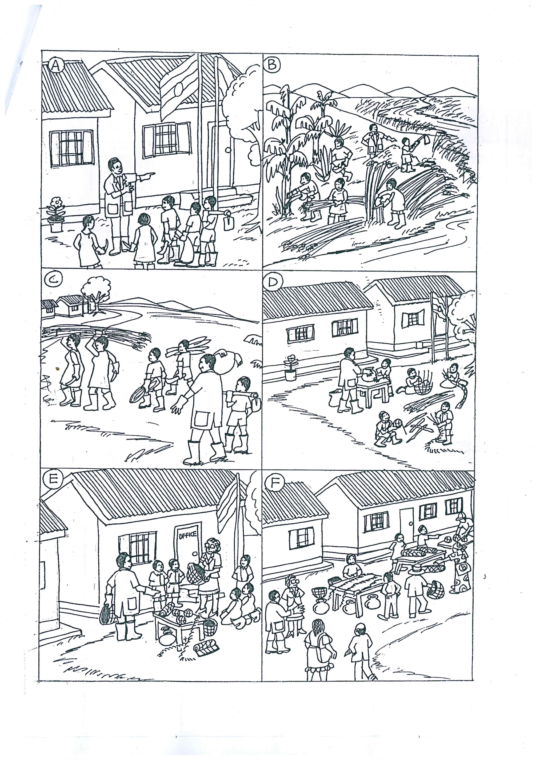

1. Picture A: …………………………………………………………………………….

……………………………………………………………………………………………

1. Picture B: …………………………………………………………………………….

……………………………………………………………………………………………

1. Picture C: …………………………………………………………………………….

……………………………………………………………………………………………

1. Picture D: …………………………………………………………………………….

……………………………………………………………………………………………

1. Picture E: …………………………………………………………………………….

……………………………………………………………………………………………

1. Picture F: …………………………………………………………………………….

……………………………………………………………………………………………

1. Why have the pupils and their art teacher worn gum boots in the picture?

……………………………………………………………………………………………

……………………………………………………………………………………………

1. Who are the people viewing the pupils’ craft in picture F?

……………………………………………………………………………………………

……………………………………………………………………………………………

1. How does the head teacher feel towards the pupils in picture E?

……………………………………………………………………………………………

……………………………………………………………………………………………

1. Suggest a suitable title to the picture.

……………………………………………………………………………………………

……………………………………………………………………………………………

1. **The composition below is in a jumbled order. Rearrange the sentences below to form the correct order of the composition about “Games and Sports in Schools”.**
2. When they become physically fit, they live in good health.
3. The activities also promote love and cooperation among learners.
4. Every school must have games and sports for their learners.
5. To begin with, games and sports help learners to be physically fit.
6. This is because they are important to the learners in many ways.
7. It is interesting for a school to have loving and cooperative learners.
8. Living in good health enables learners to study well.
9. Lastly, games and sports develop talents of learners.
10. As a result of studying well, the learners are able to perform well in class.
11. Those whose talents are developed usually become great sports people in future.

…………………………………………………………………………………………………….

…………………………………………………………………………………………………….

…………………………………………………………………………………………………….

…………………………………………………………………………………………………….

…………………………………………………………………………………………………….

…………………………………………………………………………………………………….

…………………………………………………………………………………………………….

…………………………………………………………………………………………………….

…………………………………………………………………………………………………….

…………………………………………………………………………………………………….

…………………………………………………………………………………………………….

…………………………………………………………………………………………………….

…………………………………………………………………………………………………….

…………………………………………………………………………………………………….

…………………………………………………………………………………………………….